Purpose of the NPSC Membership Network

The NPSC is a network of individuals who value and actively work to promote prevention and research-based evidence for improving social conditions. As such, it is critical that we have a platform for sharing opportunities and information with one another for advancing prevention science in the national priorities for policy and research. The hope is that this platform can provide a vehicle for networking members to bridge the prevention science and policy gap. Several guiding principles support the goals for the NPSC membership network:

Information Exchange and Discussion
Members’ involvement in multiple networks facilitates exchange of information and resources.

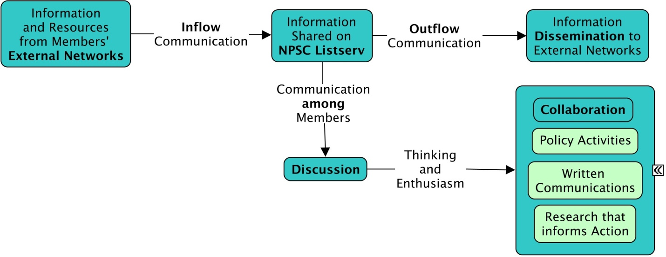
Inflow of information to NPSC members
The primary tool currently available for these purposes is the Basecamp Listserv. Listserv subscribers may use it as extensively or as little as desired, depending upon the level of involvement members wish to have.
Members may share information about:
- Opportunities for collaboration between members (e.g., new research), calls for funding or research proposals, skill development (e.g. applicable webinars), job openings, or other professional development experiences (e.g. request for coauthors on a white paper)
- Current events that initiate discussion among members (e.g., proposed legislation for human service reform)
- Tips for communicating research outside academia to public and private sectors
- Requests for volunteers that help address specific needs and goals related to the coalition’s mission
- Ideas for group activities that advance prevention research or policy (e.g., share ideas about a topic for a new op-ed)
- Issue-specific campaigns in which members can become involved (e.g., calls to action, such as letter writing to House Representatives)
- Requests for information from other members (e.g. resources about juvenile justice)
- Other posts that promote general discussion and problem solving about social issues and promote new ideas for action and collaboration

Information outflow from NPSC members to broader networks
While we expect that members will share information they glean from external networks, we also expect that members will actively disseminate information from the NPSC listserv to their other networks. Ideally, coalition products (e.g. white papers) and other opportunities that advance prevention science in national priorities will be disseminated broadly. Please share information with other professional networks and through other communication channels (email, social media) when that information is applicable to the interests of those external networks.

Sense of Community – We expect that discussion between members – on and off the listserv – will help to promote greater sense of members’ identity with the NPSC’s vision and will enhance members’ engagement in the coalition’s efforts over time. Discussion may be informal as long as it is collegial. We hope that communication between members’ will promote collaboration in activities that are directly related to bridging research, practice and policy and will lead to the development of research activities that draw on members’ interdisciplinary, cross-sector, and applied expertise.

Empowerment – We recognize that many professionals, including researchers, practitioners, and staff in public agencies may be wary about engaging in political activities that violate federal regulations. The NPSC aims to clarify the types of activities that professionals may engage in without risk to their professional obligations. Such activities may include educating staff in government agencies and policymakers through research synthesis and dissemination and advocacy regarding specific research-based approaches that policymaker may consider integrating into specific legislation. Overall, the NPSC aims to build members’ skills and experience engaging in policy-related activities that have the potential to highlight how prevention science can complement national leaders’ priorities.

Power of numbers – The NPSC wishes to increase the dialogue about preventative approaches when our nations’ leaders consider solutions to pressing issues. Essential to this goal is advocacy through articulating the benefits of preventative strategies for addressing social problems. Advocacy has the greatest potential for impact when many voices synchronously contribute to the dialogue about a public issue. This is the rationale for mobilizing the NPSC network at key moments when an issue is being considered by our nation’s leaders. We also seek to mobilize networks of our affiliate organizations when calls to action are issued (e.g., requesting members’ involvement in a letter writing campaign).

Rules of conduct
While we hope that the Basecamp listserv will free the flow of communication between members, rules are important for regulating unacceptable behaviors.
- Be professional. No foul or disrespectful language. Postings should not personally attack another individual or group.
- Be respectful and considerate of your colleagues in your postings. If you disagree or become upset with someone's response or use of the list, reply to that person directly when appropriate.
- Do not recruit coalition members for the purpose of participating in a study that has not been approved by the Executive Committee (contact Neil and Denni). Approval will be based on evaluative benefit to the coalition.
- Do not use the listserv for proprietary benefit (e.g., marketing a program for profit; offering fee for service). Do not solicit, promote, or attempt to sell commercial products or services.
- Do not promote particular political candidates or partisan agendas - it is a violation of our 501(c) status.
- Violation of the rules may subject the offending individual to removal from the listserv.

Other Etiquette Considerations
- Do not use the listserv for conversation with individuals. The listserv should be used for sending messages to all subscribers, not for one-on-one messages between individuals.
- Use a brief descriptive title. Titles that are too long are not readable. Titles that are vague are not compelling to readers.
- Post things that have a clear link to prevention. If the link is not clear (e.g., the information pertains to remediation or intervention), please reconsider posting or make the link to prevention more clear.
- Proof-read your message before sending to check for clarity and typos.
- If you wish to reply to the original sender rather than the whole listserv, find their email on Basecamp under “invite more people”, which lists all those who receive the emails. It lists names with pictures when listserv recipients choose to update their individual profile.
- If the amount of mail becomes cumbersome, rather than leaving the list, consider receiving the digest form of the list. Instead of getting each email individually, you will receive a summary email at the end of each day. Adjust your settings on Basecamp under “Me” “ My Basecamp Settings”.

